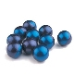
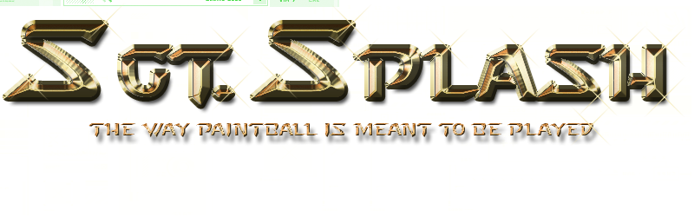
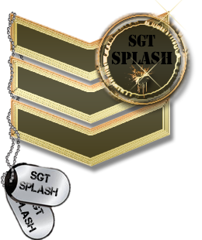
--------------------------GAME PLAY EVENTS--------------------------
SESSION | EVENT TYPE | EVENT DURATION
1ST SESSION | CQB ELIMINATION | 5 MIN
Elimination style speedball event, in small area of field.
When shot you lift up weapon in air, and leave the field of play.
10 MINUTES BRAKE
2ND SESSION | CTF CENTRE | 10 MIN
Aim is to Capture the Flag in the Centre Base and Return it to your own Base.
When Shot you lift weapon in air, and return to own base to respawn.
5 MINUTES SIDE CHANGE
3RD SESSION | CTF CENTR | 10 MIN
Aim is to Capture the Flag in the Centre Base and Return it to your own Base.
When Shot you lift weapon in air, and return to own base to respawn.
10 MINUTES BRAKE
4TH SESSION | CTF BASES | 10 MIN
Aim is to Capture the enemies Flag from his base and bring it back to your own base while your flag is still there.
When shot you stand still and wait for team member to come and tag you.
5 MINUTES SIDE CHANGE
5TH SESSION | CTF BASES | 10 MIN
Aim is to Capture the enemies Flag from his base and bring it back to your own base while your flag is still there.
When shot you stand still and wait for team member to come and tag you.
10 MINUTES BRAKE
6TH SESSION | ATTACK AND DEFEND | 10 MIN
Aim is for one Team to take up defensive positions on the hill while the other team must take control of the hill before time runs out.
When attacking team members is shot they return to home base to respawn.
When defending team members is shot the leave the field of play.
5 MINUTES SIDE CHANGE
7TH SESSION | ATTACK AND DEFEND | 10 MIN
Aim is for one Team to take up defensive positions on the hill while the other team must take control of the hill before time runs out.
When attacking team members is shot they return to home base to respawn.
When defending team members is shot the leave the field of play.
10 MINUTES BRAKE
8TH SESSION | ZOMBIE MODE | TIME THAT IS LEFT
You choose what modes you would like to play, if there is still paint and time left.

