
INDEMNITY AND PARENT CONSENT FORM
MAKE SURE YOU READ THE FOLLOWING, AS WELL AS THE RULES AND REGULATIONS
BEFORE SIGNING THE CONSENT FORM.
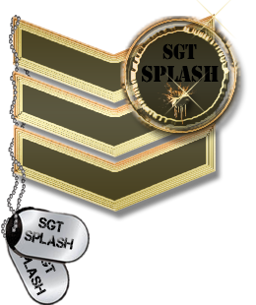
I indemnify the Owner of Sergeant splash paintball (SSP), its directors, staff members, sub-contractors and land owners on whose property any activity may be hosted, from any and all claims, notions, law suits procedures, costs expenses, damages and liabilities, including lawyer’s fees and accrued interest arising out of, connected with, or resulting from me or my children participating in any activity or event hosted or organized by SSP. I understand and accept that intense physical and mental exertion may occur during the course of these activities and therefore I further warrant that I and / or my children do not have any medical conditions that in any way may endanger me and / or other players, prior to, during and / or after participation in the activities.
- WE THE UNDERSIGNED HAVE READ AND FULLY UNDERSAND THE ABOVE TEXT AND PLAY PAINTBALL GAME AT MY / OUR OWN RISK.
- PARENTAL OR LEGAL GAURDIANS CONSENT IS REQUIRED FOR PERSONS UNDER 18 YEARS.
- PERSONS WISHING TO SIGN CONSENT FOR CHILDREN OTHER THAN THEIR OWN MUST ENSURE THAT THEY HAVE THE OTHER PARENTS CONSENT TO DO SO.
- IF NOT YET I WILL MAKE SURE I HAVE READ ALL THE SAFETY RULES AND FULLY UNDERSTAND, AND WILL ABIDE BY THEM AT ALL TIMES.
- I WILL ALSO MAKE SURE TO NOT BY ANY MEANS DAMAGE ANY OF THE EQUIPMENT AND LOOK AFTER THEM BY ALL MEANS.
- AS I KNOW PAINTBALL IS AN ACTION SPORT AND INJURIES MIGHT OCCUR AND I AM AWARE OF THAT AND STILL ARE WILLING TO PARTICIPATE.
PLAYER NR | NAMES | TEL NR | SIGN | DATE | ID NUMBER
1
2
3
4
5
6
7
8
9
10

