

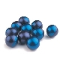
SPECIAL PRICE PACKAGES
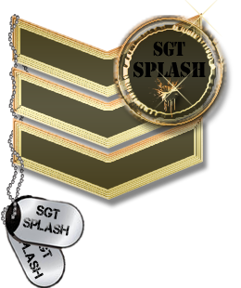  MEGA PLAYERS PACK | JUNIOR PLAYERS PACK
Paintballs x 500 = R100 | Paintballs x 200 = R40
9oz Co2 filled = R15 | 9oz Co2 filled = R10
Gear Rental R30= (for 2 hours) | Gear Rental R30 = (for 2 hours)
Field Rental R30= (for 2 hours) | Field Rental R30 = (for 2 hours)
Total = R175 | Total = R110
Gear for extra Hour = R15
Field for extra Hour = R15

Co2 REFILLS
R1 per oz

OWN GEAR
Field Rental = R30 [2 hours]

BUY PAINT FROM FIELD
 | FIELD PAINT | PREMIUM PAINT
100 round Pod | R30 | R40
500 | R90 | R100
2000 | R300 | R340

